To Kill a Mockingbird: CP iPhone app Project
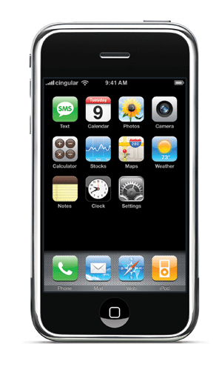
Your final project for To Kill a Mockingbird is to bring the characters to life in 2012 by giving them a little technology at their fingertips. You are going to pick a character from the novel and create iPhone Apps that are appropriate to that character. Your completed project should show an understanding of the plot, characters, conflicts, and themes presented in To Kill a Mockingbird.
Requirements:
- This is an individual project. You will choose three of your apps to present to the class on Friday, May 11th.
- You will create a total of SIX apps that pertain to the character of your choice. Each app should have an appropriate/connecting picture and a description as to how this app will be of value or use to your character.
- What are your apps? I am so glad you asked!
  - Create one app that connects to an internal conflict that your character faces in the novel.
  - Create one app that connects to an external conflict that your character faces in the novel.
  - Create two apps that connect to one of the following themes presented in the novel: justice, loss of innocence, prejudice (racial/gender/social), social class division, or hypocrisy.
  - Create two apps of your choice. These apps should connect to your character’s personality and what we learned about his/her interests, habits, and/or specific events that he finds himself in during the course of the novel.
On the back of this sheet is a brainstorming area for you. Today in class, you are to come up with your apps and descriptions. We will be using computers on Thursday (4/26), Wednesday (5/9), and Friday (5/11) for you to work on the project. I highly recommend that you bring a flash drive with you on those days so you can save your work and take it home to tweak. Your completed project is DUE Friday, May 11th. You will need to have dropped it into my inbox on the school’s shared drive by the END of the class period!
Extra Credit: For the “extra” 10 apps, you can add a pic, name, and information. You can earn a bonus point for each additional app (up to 10 bonus points).

________________ iPhone
What Kind of App? | Name of App | Brief Description of App  (Your final description will need to be at least five sentence.)
Internal Conflict

External Conflict

Theme?
________________

Theme?
________________

Your Choice

Your Choice

(character’s name)

