Accessing Your School Google Drive Account

- Go to connect.hallco.org

- Use your school computer login information to login.
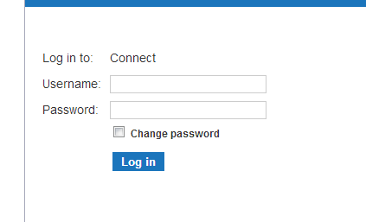
- Your screen will look different from mine, but look for and click on the Google Drive Logo:
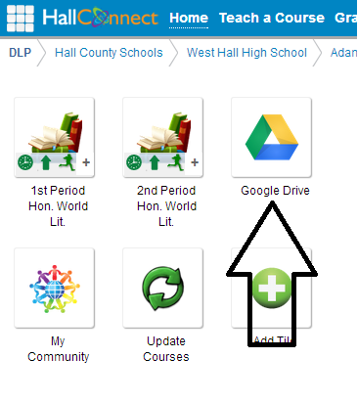

Instructions for Students to Create a Google Drive Folder for Your Class

- Choose “Create” and then “Folder”
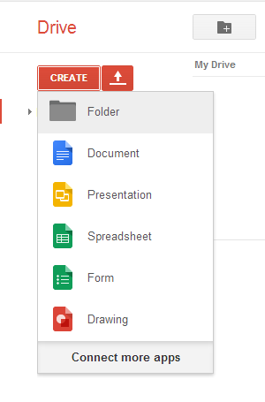
- Name your folder “Last Name, First Name, Period” with your name and click “Create.”
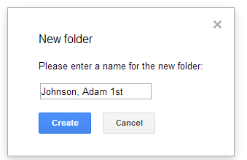

(Go to next page)

- Drop the menu down next to your name, choose “Share” and then “Share”
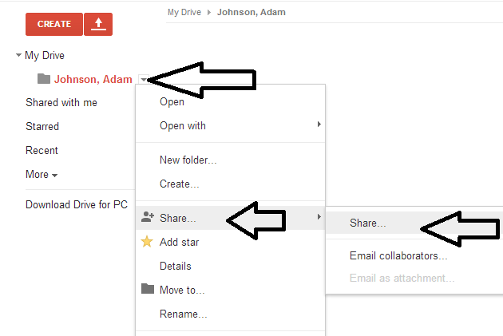

- Under “Sharing Settings,” in the “Invite People” box, type your teachers name until you see their email address. Unclick “Notify people via email” and then choose “Can Edit.” Then click “Share and Save.”
