ehhslibrary.com

Screencast-O-Matic Instructions

Creating a screencast is easy! It is a great tool for showing lessons to students even when they are not at school. You can also create them in advance or while you are at home to share information with students!
Before using Screencast-O-Matic.com, you will need to have headphones with a microphone ready.
- Go to screencast-o-matic.com. Here you can use the Screencast-O-Matic directly from the page or download the software. It is free to use!
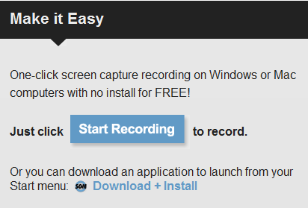

- After downloading Screencast-O-Matic or when you are ready to record a screencast, watch this quick and EXTREMELY helpful tutorial below:
http://screencast-o-matic.com/u/h/start-recording

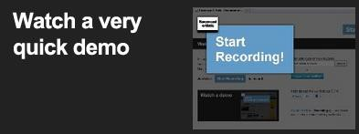

Please let us know if you need any help recording screencasts.

