Create a READ poster

Choose an important scene in your book to recreate and make into a READ poster. Be sure to make it interesting so other students will want to read the book!

What to do:
- Use a digital camera to take a high-quality picture. (Camera phones do not work best for this assignment.)
- Picture can be taken vertically or horizontally.
- Leave “dead space” in the picture to write the phrase READ @ the EHHS Media Center
- Include the book somewhere in your scene.
- Save the picture.
- Upload the picture to picmonkey.com to edit.

How to save:
- Be sure to save a copy of your original picture AND your edited picture.
- Save your edited picture with this name: firstnamelastnameREAD.jpg
  - Example: beccahambyREAD.jpg
- Save to your MyFiles or a Flash Drive

What to write:
- Your name and the book title and author
- A short summary of the book
- An explanation of why you chose that particular scene for your READ poster
- Save this document as firstnamelastnameREAD.doc Example: beccahambyREAD.doc
- Save to your MyFiles or a Flash Drive

Turn it in:
- Give your teacher a copy of the picture and word document on a flash drive or printed, or email the documents to them
- Email the edited picture file and written assignment to rebecca.hamby@hallco.org

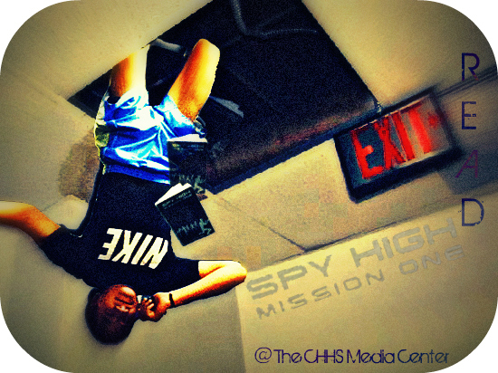
Examples:


