ehhslibrary.com

Today’s Meet Instructions

- Go to Todaysmeet.com.

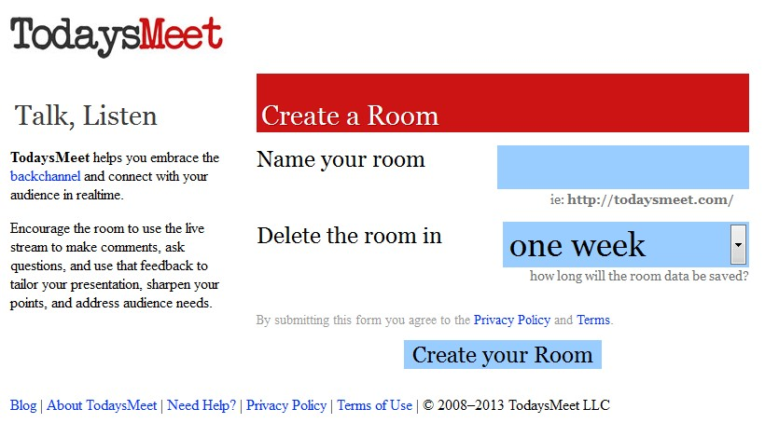
- Fill out the information needed to create your room! First, name the room. This will be the link that the students will use to go to the room.
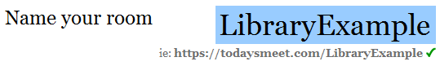
- You can also decide how long your room will available. This also includes the conversation from the room. You can have the room available from one hour-one year.
- You will need to share your custom Today’s Meet link with your students. This way they can attend. For example:
- Once you and your students go to the link, everyone is prompted to create a name. It is important to instruct your students to use their full names to get credit. You can type any name you want so if you leave it open-ended, you may get some crazy names!

- This is where teachers and students can type what they want to say in 140 characters or less.
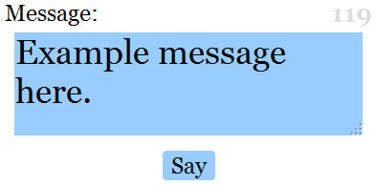
Once you click the “Say” button it will show up in the chat.

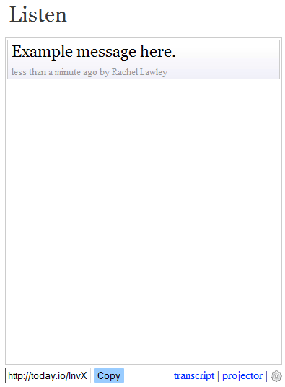

- Once you are finished chatting with students, you can see the entire transcript by clicking on “transcript” below the chat. This way you can review who was participating, who was present, etc.

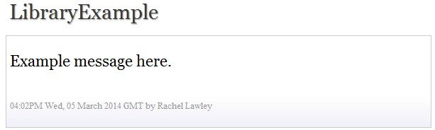

Before using TodaysMeet.com, it is a good idea to share instructions for how to use this with your students. You can also set up a permanent room for students to ask questions during snow days or set up a time where all students are participating in a chat.

