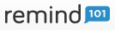ehhslibrary.com

How to Use Remind 101

Remind 101 is a free tool that teachers and students can use to communicate. Teachers, set up these groups ahead of time. You can also put more information about joining your Remind 101 groups on your Teacher Page. Remind 101 is:
- Safe and anonymous (No one can ever see any person’s phone number)
- Free
- Easy to use (there is an app and a website you can use!)
- No group texts or replies (No one can reply to your message-they can only view it)

- Go to www.remind101.com. Fill out the information needed and then click “Sign Up.”

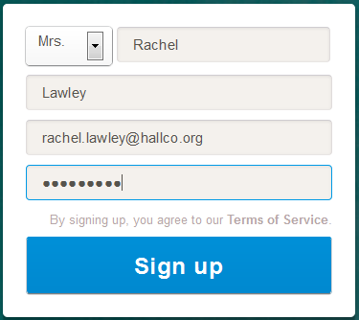
- Now you will set up your classes. You can always edit these classes or add more at a later time.
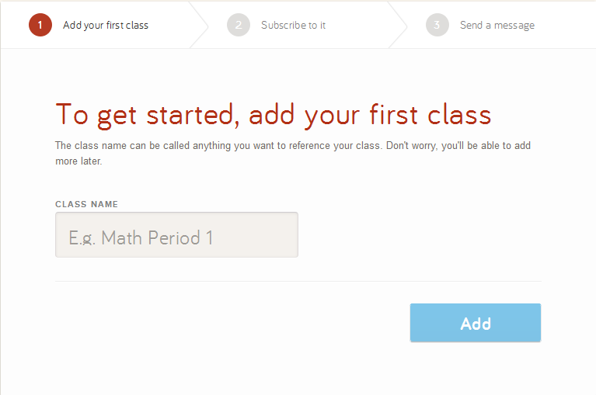

- Next, you will use your phone and subscribe to your created class. This way you will see the updates you send out as well.
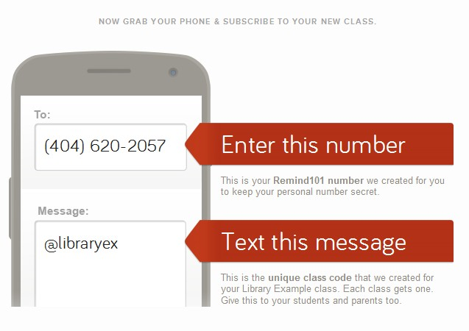
- This is what it will look like on your phone:

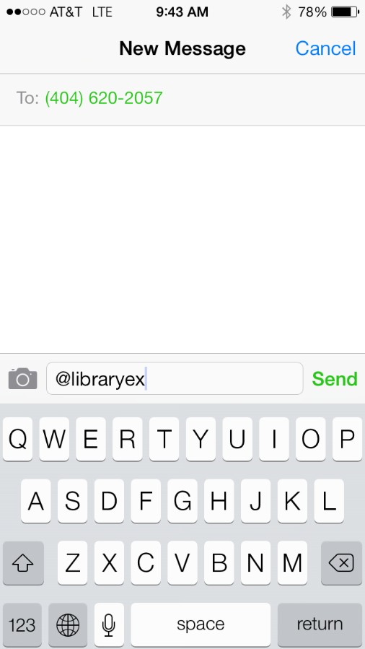

- This is the reply you will see (this is also what students and parents will see when they subscribe!):
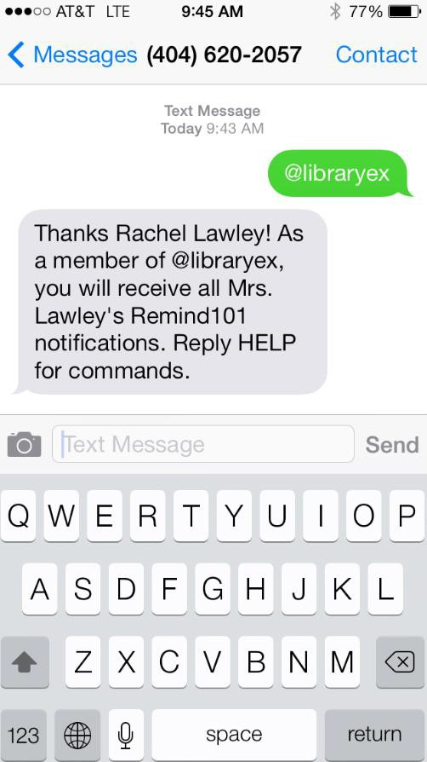
- Now, send yourself this sample message. This will show you what your notifications will look like to your parents and students.
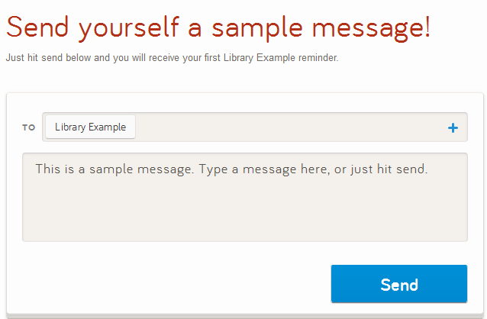

- Now that you have set up one class and sent an example message, you will now be at the main screen of Remind 101. This is where you can add classes, send messages, and more. First, you will need to create every single class. It is a good idea to have separate groups for each period of the day. If you teach the same subject to multiple classes and have a message, you can always combine groups later. To create a new class, click the “Add a New Class” button on the left side of the screen.
- Each class will have its own unique number for students to sign up for. It is important to show the different sign up directions for each class (if each class has its own page on your Teacher Page, it is a good idea to put the picture of how to sign up on each page! This way parents can sign up as well). You can even put the picture of how to sign up on your syllabus or on a handout for students to take home. Plus- students will LOVE to get their phones out in class… so they can sign up while in class! Show your students this information:
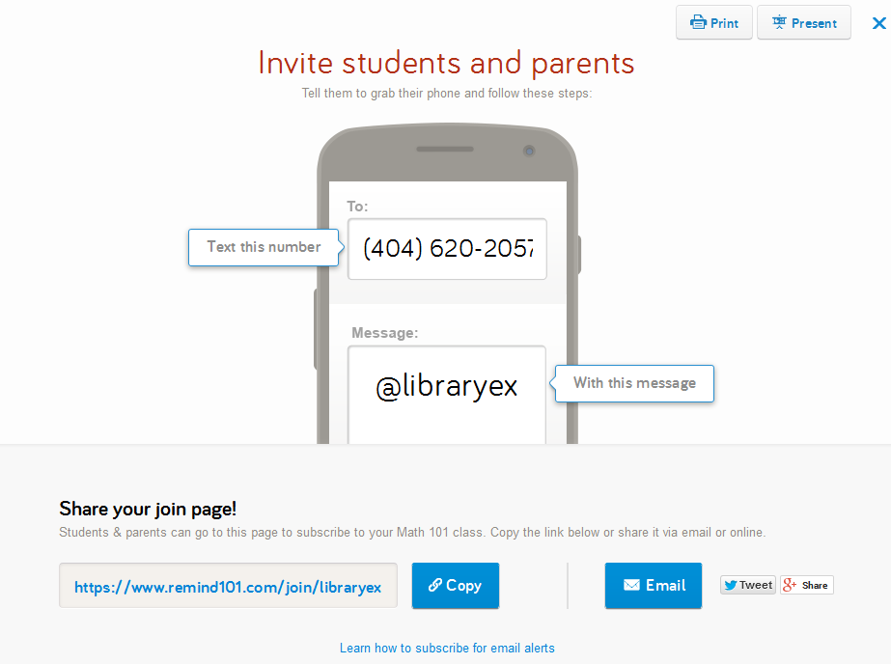
You can print this information, embed this information, and email this information! If a student does not have a phone or also wants to subscribe to email alerts, click “Present” (above) and show them this section:

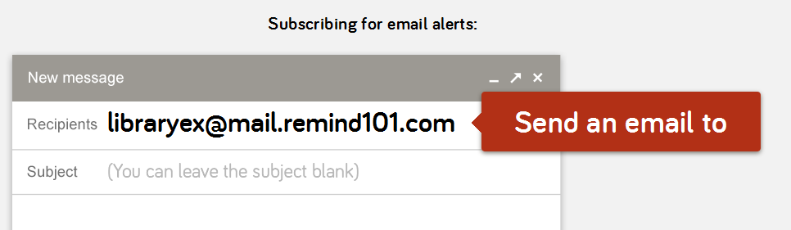

- It also is a good idea to download the Remind 101 app to your phone. This way you can send reminders even if you are not at a computer. This is what the app looks like:
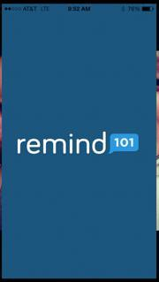
The app has the same capabilities of the website!
- You are now ready to send updates to both students and parents for each class. If you need any assistance setting up Remind 101 to your class, please let us know!

Remind 101 is also great for:

  - Coaches (Send information about practice, games, etc. to both players and parents!)
  - Club sponsors (Send reminders about club information to members!)

