How to Embed Your Twitter Feed on Your Website

- Go to your teacher page and log-in to edit your page. If you have a teacher page with Hall County, this tutorial is based around that website. If you build your teacher page in another website, let us know and we can help you embed your twitter feed there!
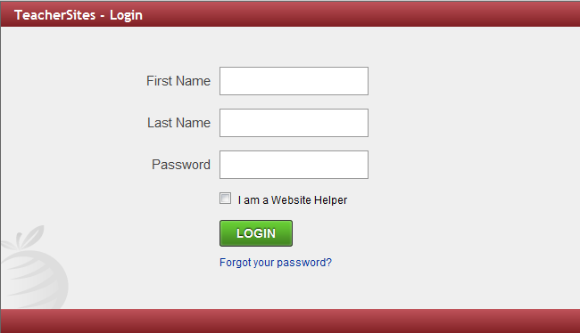
- Once you are at the editing screen, you will see two options. One option enables you to edit the website in html and the other is how you and others will view the website (design option). When you want to embed your twitter feed, you will need to be in the html mode.
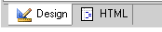

- The html mode makes it more difficult to see what goes where. The best way to decide where to put your twitter feed is to find the text that will be above the twitter feed. This way you can ensure that your feed will be in the correct spot. For this example, I will put the twitter feed right below where it says “Home of the West Hall Spartans!”
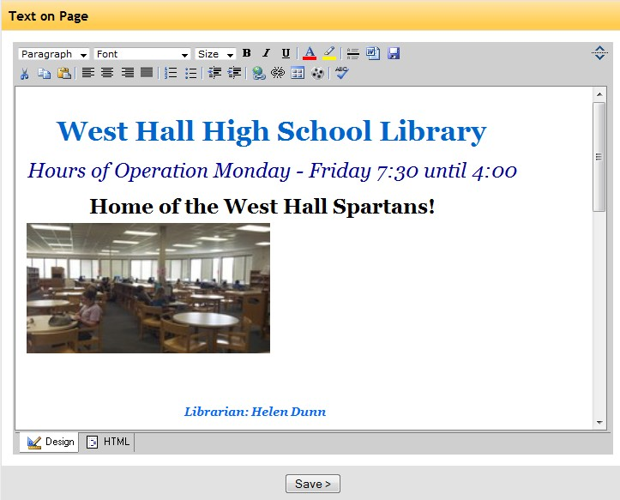

- The html view makes this portion of the website look a little complicated. I just found where I could see “Home of the West Hall Spartans!” and looked after that to find the ending of the html for that text.
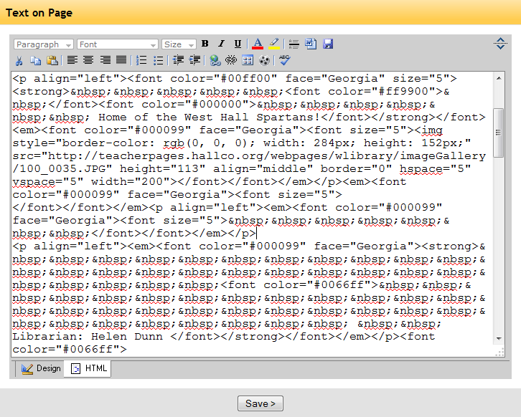
- Where it says </p> is the end of the paragraph/text—that is where I will paste the html code of my twitter feed. Now, go back to your twitter to find your html code (you will need to be logged in). Once you are logged in, find the tab that says “Settings” –it will be at the top right of your page.
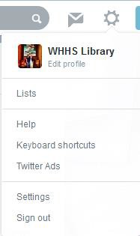

- Once you have clicked on “Settings” you will see several options. Click on “Widgets” to make a widget for your website. Then, click on “Create New Widget.”
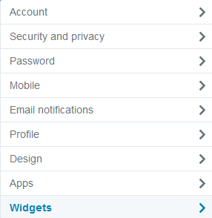
- This option allows you to create several types of twitter feeds for your website. You can put your own tweets on your website (Recommended) or you can put all tweets with a certain hashtag (this works well if you have a “class” hashtag). There are also other options that you can play around with to see what works for you.
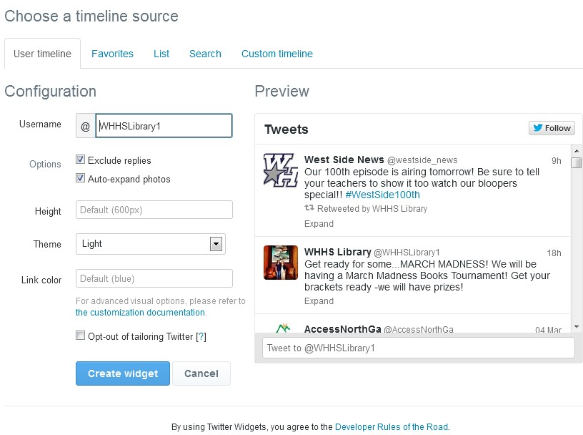

- Make sure that your username is in the username slot. You can also change the height, theme (look), link colors, and more. The preview of what it will look like on your website will be on the right. Once you are satisfied, click “Create Widget.”
- This page will look similar to the editing page. It will now have an html code already selected for you below the preview. Copy the code. It will look something like this:
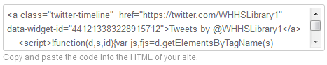
- Once you have copied the code, go back to your teacher page. It should still be open to the html editing option. Paste (Ctrl+V) your code right after the </p> where the text ends (this may be different for each person!).
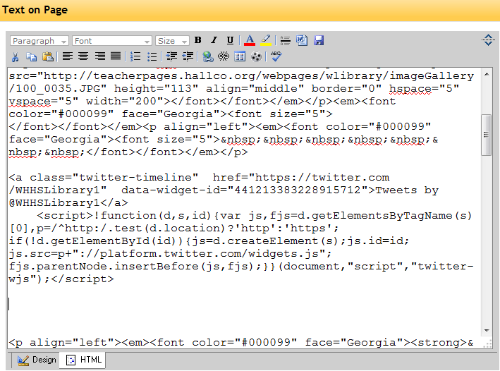

- Now, click on the “design” mode. You should see something that says “Tweets by
@YourUsername” where you pasted your html. Click on “Save” and then “View Page.” You should now see your twitter feed on your page. All of your tweets will automatically be shown here!
Please let us know if you need any help with this! We are happy to help!

