Destiny Catalog Tip Sheet
Logging into Destiny
- Access the Destiny Catalog at https://destiny.hallco.org/
- Choose East Hall High School from the list
- Click on “login” in the top right-hand corner
- Enter your school computer credentials
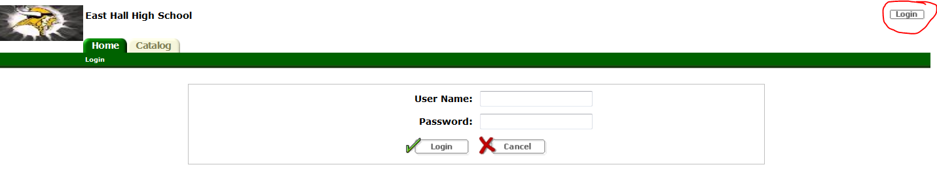
Searching for Books
- Click the Catalog tab
- Type in the title of a book or a subject and press Enter, or you can press one of the buttons below the search box
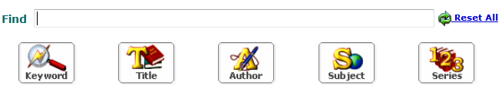
Resource Lists
- Click the Catalog tab
- Click Resource Lists on the left-hand side of the screen
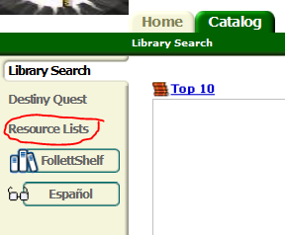
- Create your own list or click Public Lists to see ones that are already made.
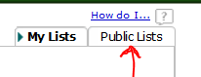

- Click on any of the lists to see books in those groups.
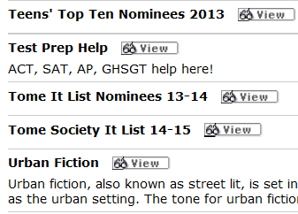
- If you see a book you like when you are searching you can add it to your personal list by clicking the Add to this List button on the title listings. Just be sure that the Selected List is your Personal List.
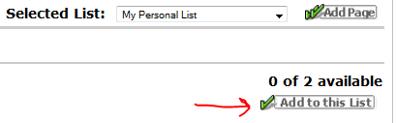
Placing a Book on Hold
If a book that you want to read is checked out, you can place it on hold and you will be contacted when it comes back in.
- Login and use Destiny to search for the book you want
- Click on the book title to open up the Book Details Page
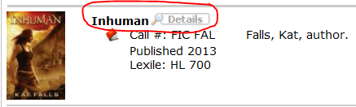
- On the bottom of the right-hand menu, click on Hold It, then click Save.
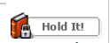
- NEVER place a book on hold from another school (if you accidently searched the district instead of our school)!
Other Cool Things You Can Do in Destiny
- Recommend a book to a friend
  - Login and use Destiny to search for the book you want
  - Click on the book title to open up the Book Details Page
  - On the Book Details page, look for the Recommend button in the right-hand menu
  - Type the name of the person you want to recommend the book to and click Go!
  - Click on the person’s name in the list, and click save.
- Write a review of a book
  - Login and use Destiny to search for the book you want
  - Click on the book title to open up the Book Details Page
  - Click on the tab titled “Reviews”
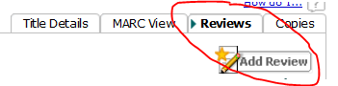
  - Click Add Review
  - Rate the title by choosing 1 to 5 stars
  - Write comments about the book if you want to provide more details – keep it clean, use good grammar.
  - Click Save
- Add a book to the library’s Wish List
  - Login to Destiny and go to the Catalog tab
  - Search for ANY book or subject you want
  - Click on ANY book title to open up the Book Details Page
  - Click on the Wish List button on the right-hand menu
  - Be sure to click the “New title” radio button!!!
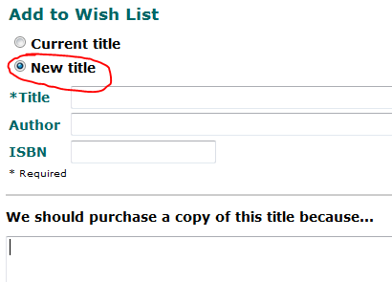
  - Enter the Title (and Author if you know it) of the book you want us to purchase. Also, add a short note about why we should get this book (in a series you’ve started, heard about it from a friend, etc.)

