Creating a Twitter Account

- Go to twitter.com.
- Fill out the information to create a twitter account:

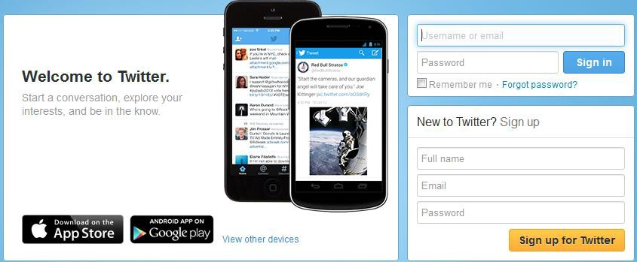
- Twitter will ask you to create a username, password, and more. If you use your Hall County credentials and your laptop, you can have twitter stay signed in on your computer. There is also an app for smart phones so you can use twitter from your phone.
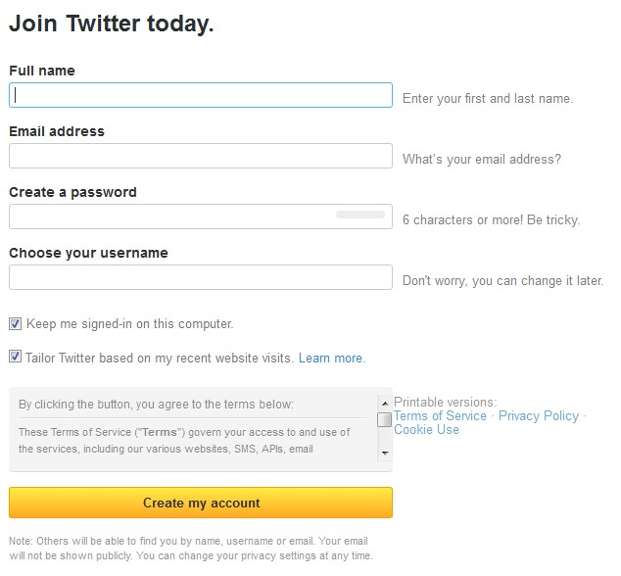

- Once you create your account, you can choose other twitter accounts to “follow” to make sure you are updated on your tweets. Give your students your account name (For example, the EHHS Library is: @EHHSLibrary) so that students can find you for updates.
- When you want to tweet, click inside the textbox where it says “Compose New Tweet.”

When you tweet, you have up to 140 characters. You can also use “hashtags” to group your tweets together. For example, you can use #EHHSLibrary if you want to be able to find all tweets about the library grouped together. Share with your students the class hashtag so they can easily find all of your tweets.

Ways to Use Twitter in (and out of!) the Classroom:

- Communicate with students from anywhere at any time (this is great for reminders about assignments, tests, due dates, and more). This is also nice because all tweets and communication can be public so you can answer one student’s question and all students can benefit.
- Follow and retweet tweets from other accounts to share with students (this helps students find resources and more information about topics in class).
- Tweet links to important info and websites like your Teacher Website, articles, websites about EHHS and Hall County, and more.

Already have an account?

- Follow other twitter accounts from EHHS faculty and staff as well as Hall County Schools (@Hall_Schools).
- Post your account name as well as any “class hashtags” in your classroom and encourage students that have accounts to follow you for class updates.
- Embed your twitter feed on your Teacher page. Not all students will want to follow teachers. If you embed your feed on your Teacher page, they can go there to access your tweets. This is also great for parents to see updates.
- Remember to be careful about what you tweet… remember all standards for teachers apply on social media as well as privacy laws (tweeting pictures and names of students).

